**Final Project Report for ELE: 581**

Name: Muhammad Enayetur Rahman

Student ID: 100635221

Data set: [Airfoil Self-Noise Data Set](http://archive.ics.uci.edu/ml/datasets/Airfoil+Self-Noise)

**Part A:**

Total 6 attributes are:

1. Frequency, in Hertz
2. Angle of attack, in degrees
3. Chord length in meters
4. Free-stream velocity, in meters per second
5. Suction side displacement thickness, in meters

And the final output is:

1. Scaled sound pressure level, in meters

Here is the basic statistical summary for each attribute. Attribute ‘Sound level’ would be my *final output regression attribute*.

In the summary, for each attribute minimum value, 1st Quartile, Median value, Mean value, 3rd Quartile value and Maximum value are given using R’s command:

* *Summary(dataframe$attribute)*

Histogram of each attribute is found using R’s command

* *hist(dataframe$attribute)*

**Summary and Histogram of each attribute:**

|  |
| --- |
| **frequency** |
| Min. : 200 |
| 1st Qu.: 800 |
| Median : 1600 |
| Mean : 2886 |
| 3rd Qu.: 4000 |
| Max. : 20000 |

**Attribute: Frequency**

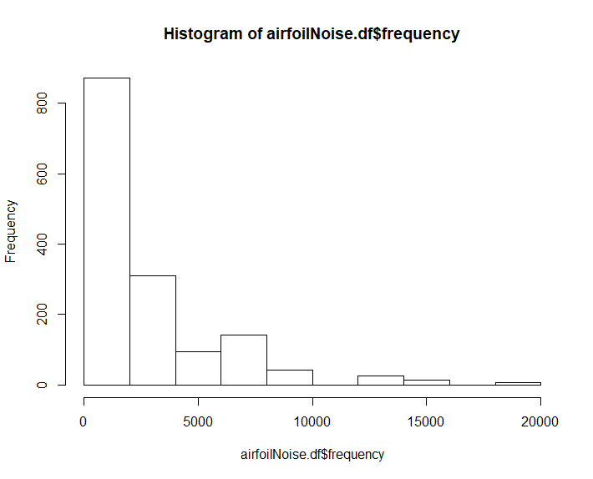

Figure 1: Histogram of Attribute Frequency

**Attribute: Angle of attack**

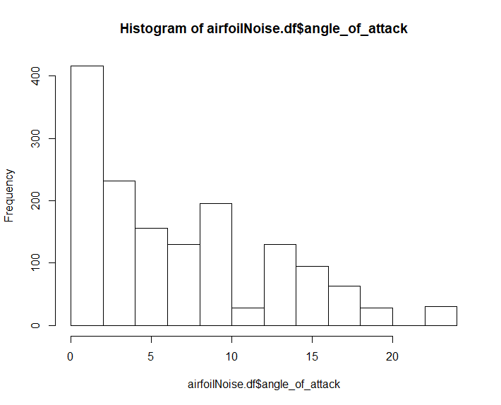

Figure 2: Histogram of Attribute Angle of Attack

|  |
| --- |
| **angle_of_attack** |
| Min. :0.000 |
| 1st Qu.:2.000 |
| Median :5.400 |
| Mean :6.782 |
| 3rd Qu.:9.900 |
| Max. :22.200 |

|  |  |  |  |  |  |  |  |  |
| --- | --- | --- | --- | --- | --- | --- | --- | --- |
| |  | | --- | | **chord_length** | | Min. : 0.0254 | | 1st Qu.: 0.0508 | | Median : 0.1016 | | Mean : 0.1365 | | 3rd Qu.: 0.2286 | | Max. : 0.3048 |   **Attribute: Chord Length** | Figure 3: Histogram of Attribute Chord Length |
| **Attribute: Free Stream Velocity** | |
| |  | | --- | | **free_stream_velocity** | | Min. : 31.70 | | 1st Qu.: 39.60 | | Median : 39.60 | | Mean : 50.86 | | 3rd Qu.: 71.30 | | Max. : 71.30 | | Figure 4: Histogram of Attribute Free stream velocity |

|  |  |
| --- | --- |
| **Attribute: Displacement Thickness** | |
| |  | | --- | | **displacement_thickness** | | Min. : 0.0004007 | | 1st Qu.: 0.0025351 | | Median : 0.0049574 | | Mean : 0.0111399 | | 3rd Qu.: 0.0155759 | | Max. : 0.0584113 | | Figure 5: Histogram of Attribute Displacement Thickness |
| **Attribute: Sound Level** | |
| |  | | --- | | **sound_level** | | Min. : 103.4 | | 1st Qu.: 120.2 | | Median : 125.7 | | Mean : 124.8 | | 3rd Qu.: 130.0 | | Max. : 141.0 | | Figure 6: Histogram of Attribute Sound Level |

**Graphs of each independent variable:**

Graph of each attribute is found using R’s command

* *Plot(dataframe$attribute)*

The graphs of all of the attributes are given below:

|  |  |
| --- | --- |
| **Frequency** | **Angle of Attack** |
| **Chord Length** | **Free stream velocity** |
| **Displacement Thickness** | **Sound level** |

**Part B:**

For “Linear” kernel the following table information is used: Gamma = 0.2.

|  |  |  |  |  |
| --- | --- | --- | --- | --- |
| **ID** | **Kernel** | **Cost** | **Epsilon** | **Root mean Squared Value (RMSE)** |
| 1 | Linear | 0.001 | 0.1 | 5.366429 |
| 2 | Linear | 0.01 | 0.1 | 4.83299 |
| 3 | Linear | 0.01 | 0.4 | 4.817667 |
| 4 | Linear | 0.1 | 0.1 | 4.872883 |
| 5 | Linear | 1 | 0.1 | 4.876625 |
| 6 | Linear | 1 | 0.5 | 4.816702 |
| 7 | Linear | 1 | 0.6 | 4.811977 |
| 8 | Linear | 10 | 0.1 | 4.876962 |
| 9 | Linear | 10 | 0.5 | 4.816691 |
| 10 | Linear | 100 | .1 | 4.876561 |
| 11 | Linear | 100 | .5 | 4.816847 |

Code attached (File: regression_linear.R)

For polynomial Kernel: Gamma = 0.2

|  |  |  |  |  |  |
| --- | --- | --- | --- | --- | --- |
| **ID** | **Kernel** | **Cost** | **Degree** | **Epsilon** | **Root mean Squared Value (RMSE)** |
| 1 | Polynomial | 10 | 2 | 0.1 | 5.627001 |
| 2 | Polynomial | 10 | 2 | 0.8 | 5.545119 |
| 3 | Polynomial | 10 | 3 | 0.1 | 4.400711 |
| 4 | Polynomial | 10 | 3 | 0.3 | 4.394331 |
| 5 | Polynomial | 100 | 2 | 0.1 | 5.633465 |
| 6 | Polynomial | 100 | 3 | 0.1 | 4.399498 |
| 7 | Polynomial | 100 | 3 | 0.3 | 4.392198 |
| 8 | Polynomial | 100 | 3 | 0.9 | 4.488404 |

Code attached (File: regression_poly.R)

For **Radial** kernel: Gamma = 0.2

|  |  |  |  |  |
| --- | --- | --- | --- | --- |
| **ID** | **Kernel** | **Cost** | **Epsilon** | **Root mean Squared Value (RMSE)** |
| 1 | Radial | 1 | 0.1 | 3.087114 |
| 2 | Radial | 1 | 0.9 | 3.81452 |
| 3 | Radial | 10 | 0.1 | 2.57082 |
| 4 | Radial | 10 | 0.5 | 2.798251 |
| 5 | Radial | 10 | 0.9 | 3.572354 |
| 6 | Radial | 100 | 0.1 | 2.168457 |

Code attached (File: regression_radial.R)

Two best models are from Radial Kernel: Considering other kernel’s complexity and Root Mean Squared Error (RMSE).

|  |  |  |  |  |
| --- | --- | --- | --- | --- |
| **ID** | **Kernel** | **Cost** | **Epsilon** | **Root mean Squared Value (RMSE)** |
| 1 | Radial | 1 | 0.1 | 3.087114 |
| 3 | Radial | 10 | 0.1 | 2.57082 |

**Part C:**

Using the Bootstrap, hold-out method with my top two models and 95% confidence interval, the lower and upper bound errors are given as follows:

|  |  |  |
| --- | --- | --- |
| Best Models (Radial) | **Lower Bound Error** | **Upper Bound Error** |
| **Model ID: 1 (Kernel=Radial, Cost=1, Epsilon=0.1)** | 2.901717 | 3.585302 |
| **Model ID: 3 (Kernel=Radial, Cost=10, Epsilon=0.1)** | 2.465413 | 3.138644 |

Code attached (File: regression_bootstrap.R)

1. For a total of 1000 Bootstrap samples with the 95% error confidence interval, the lower  
   bound is **2.5th percentile** which is: **25th value** of the corresponding error array and the  
   upper bound is **97.5th percentile** which is: **975th** value of the corresponding error array.  
   For Model ID: 1, the 95% confidence interval is: [2.901717, 3.585302].For Model ID: 6, the 95% confidence interval is: [2.465413, 3.138644]
2. Two models are: fD1 = [kernel = Radial, C = 1, Epsilon = 0.1] with 95% confidence interval **[2.901717, 3.585302]**, RMSE = 3.087114 and fD2 = [kernel = Radial, C = 10] with the 95% confidence interval **[2.465413, 3.138644]**, RMSE = 2.57082

we found: model ID: 3’s confidence interval is completely overlapped with the model ID: 1’s confidence interval. As a result, the performance of these two models are notsignificantly different.

To select the best models among these two, it is needed to see the other parameters  
besides RMSE. So, complexity is considered here. As a result, model ID: 1 is which has Cost = 1, Epsilon = 0.1 is much less complex than model ID: 3, which is Cost = 100, Epsilon = 0.1. So, model ID: 1 ie. **fD1 = [kernel = Radial, cost = 1, Epsilon = 0.1]** is selected.